Employing Google Online Services to Assist
in Resolving Co-References in Arabic Text
Abstract
In this paper, we examine a proposed model for resolving coreferences in Arabic text. The model employs Google translation service to serve as a mediator that can transforms back and forth natural language text between natural languages with poor resources and natural languages with rich resource. To examine the potentials of the proposed model, we selected Arabic and English as candidate languages. The experiments demonstrated promising results which might justify the exploration of such approach to solve other types of similar problems.
Introduction
Nowadays, the big technology leaders like Google, Microsoft, Facebook are making huge investments to establish and publish different types of online services that can be consumed by the global public worldwide. These services include different useful functions such as speech recognition, text translation, geographic mapping, image recognition and many others.
In this paper, we present a proposed model that can utilize the scientific breakthroughs that are achieved by the big technology providers and use the achievements to solve problems in different domains. The method we are proposing is based on a piggybacking approach were we tweak the achievements of the big providers to solve other hard problems that would require significant investments and efforts.
Related Work
In this paper, we present a proposed model that can utilize the scientific breakthroughs that are achieved by the big technology providers and use the achievements to solve problems in different domains. The method we are proposing is based on a piggybacking approach were we tweak the achievements of the big providers to solve other hard problems that would require significant investments and efforts.
The Proposed Model
Cloud Machine Learning API family
Cloud Translation API
In this paper, we present a proposed model that can utilize the scientific breakthroughs that are achieved by the big technology providers and use their achievements to solve problems in different domains. The method we are proposing is based on a piggybacking approach were we employ the achievements of the big providers to solve other hard problems that would require significant investments and efforts.

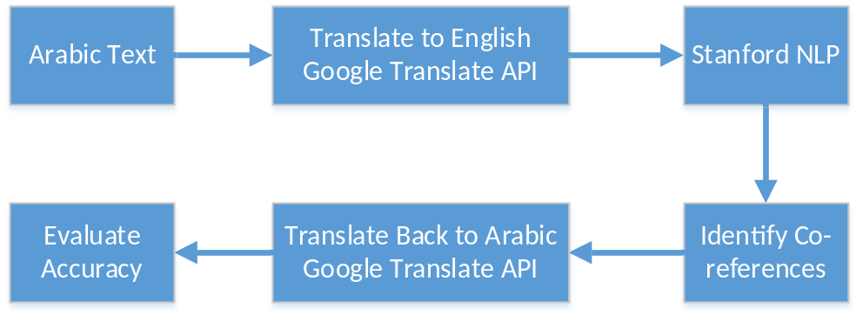

Experiments and Results
In this paper, we present a proposed model that can utilize the scientific breakthroughs that are achieved by the big technology providers and use the achievements to solve problems in different domains. The method we are proposing is based on a piggybacking approach were we tweak the achievements of the big providers to solve other hard problems that would require significant investments and efforts.

Conclusion
In this paper, we present a proposed model that can utilize the scientific breakthroughs that are achieved by the big technology providers and use the achievements to solve problems in different domains. The method we are proposing is based on a piggybacking approach were we tweak the achievements of the big providers to solve other hard problems that would require significant investments and efforts.
References

